Requirements for Sign-In webpage:

* HTML
* CSS
* PHP
* MySQL
* Xampp/Wamp server

**Listing 1**: Sign-In.html

<!DOCTYPE HTML>

<html>

<head>

<title>Sign-In</title>

<link rel="stylesheet" type="text/css" href="style-sign.css">

</head>

<body id="body-color">

<div id="Sign-In">

<fieldset style="width:30%"><legend><b>Type the following Information</b></legend>

</br>

<form method="POST" action="connectivity.php">

Employee ID <br><input type="text" name="userid" size="20"><br>

</br>

Email <br><input type="text" name="email" size="60"><br>

</br>

<input id="button" type="submit" name="submit" value="Request Credentials">

</form>

</fieldset>

</div>

</body>

</html>

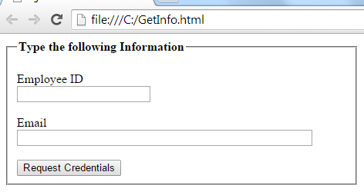

In the form we used method POST. And action to send data to another webpage. Which will be PHP Programmed webpage connectivity.php.

For a password use

Password <br><input **type="password**" name="pass" size="40"><br>

The functionality of type password shows ●●●●●●●.

Why we are using POST not GET method:

We are using POST method because it is secure. If we use GET method our data will not private. POST is commonly being used for these kind of webpages, due to its security. And when we are dealing with our ID and Password, so we should be alert from the hackers. Because the GET is being used in Phishing webpages, by which people are making fool the internet users to get their personal ID and Password.

Create file style-sign.css with the following information

/*CSS File For Sign-In webpage*/

#body-color{background-color:#E0E0E0;

}

#Sign-In{

margin-top:150px;

margin-bottom:150px;

margin-right:150px;

margin-left:450px;

border:3px solid #a1a1a1;

padding:9px 35px;

background:#A0A0A0;

width:400px;

border-radius:20px;

box-shadow: 7px 7px 6px;

}

#button{

border-radius:10px;

width:230px;

height:40px;

background:#33FF99;

font-weight:bold;

font-size:20px

}

To change the background there are 3

* Main background
* Square background
* Button background

Use color pallete to set other values

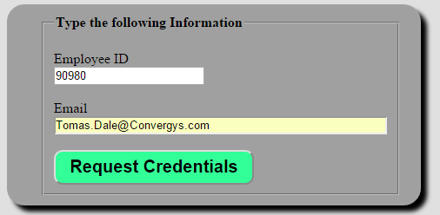

Using PHP and MySQL to get Log In user Profile page:

creating table

CREATE TABLE UserName

(

UserNameID int(9) NOT NULL auto_increment,

userName VARCHAR(40) NOT NULL,

pass VARCHAR(40) NOT NULL,

PRIMARY KEY(UserNameID)

);

Inserting data to the table UserName:

INSERT INTO

UserName (userName, pass)

VALUES

("mrbool","mrbool123");

Now we are going create a PHP programing file. In which we will get the data and check it if the ID and Password are available in the database and entered correct then the user will be able to online to the user profile page.

connectivity.php

<?php

define('DB_HOST', 'localhost');

define('DB_NAME', 'practice');

define('DB_USER','root');

define('DB_PASSWORD','');

$con=mysql_connect(DB_HOST,DB_USER,DB_PASSWORD) or die("Failed to connect to MySQL: " . mysql_error());

$db=mysql_select_db(DB_NAME,$con) or die("Failed to connect to MySQL: " . mysql_error());

/*

$ID = $_POST['user'];

$Password = $_POST['pass'];

*/

function SignIn()

{

session_start(); //starting the session for user profile page

if(!empty($_POST['user'])) //checking user from Sign-In.html if it is it empty

{

$query = mysql_query("SELECT * FROM UserName

WHERE userName = '$_POST[user]'

AND pass = '$_POST[pass]'") or die(mysql_error());

$row = mysql_fetch_array($query) or die(mysql_error());

if(!empty($row['userName']) AND !empty($row['pass']))

{

$_SESSION['userName'] = $row['pass'];

echo "SUCCESSFULLY LOGIN TO USER PROFILE PAGE...";

}

else

{

echo "SORRY... YOU ENTERD WRONG ID AND PASSWORD... PLEASE RETRY...";

}

}

}

if(isset($_POST['submit']))

{

SignIn();

}

?>